

**PERSONAL INFO**

**SEX Male**

**MARITAL Married**

**STATUS Ahiazu**

**L.G.A Mbaise**

**STATE Imo**

**COUNTRY Nigeria**

**DETAILS**

**Mini-woji, Woji,**

**Port Harcourt,**

**+234-703-721-4108**

[**https://github.com/princedev1993**](https://github.com/princedev1993) **evangelize4me@gmail.com**

**ONYEBUCHI PRINCEWILL CHIDI**



**Leadership / Employment Experience**

**Interface Developer / Front End Developer** **January 2021 - Date**

**Free Lance**

**Tools Used:** HTML, CSS (and CSS frameworks), JavaScript, TypeScript, REACTJS, Firebase, Git/Github

**Branch Manager / Coding Instructor** **September 2019 - Date**

**TeenCoders, Uyo /Port-Harcourt**

TeenCoders is a firm that builds scalable applications and educate's learners on programming and programming languages, to be top class in industries.

So far, I have trained over 500 children / teens on the basics of computer programming.

**Tools Used:** Scratch, HTML, CSS, JavaScript, PHP, MySQL, Kodu Game Lab, Comic Life, Muvizu, App Inventor, Construct3D, Python.

**SUMMARY**

Entry level IT support

professional, recently completed Google IT

support Professional Certificate. A hands-on IT program that covers troubleshooting, customer

service, networking, operating systems, system administration and IT security.

1. am self-motivated and result oriented.

**ATTRIBUTE**

* Leadership and Team Work
* Relationship Management
* Good communication & interpersonal skills
* Initiative, organized and creative
* **Customer relation management**

**HNG Frontend Developer** **May 2020 - August 2020**

**HNG NG**

Hotels NG (HNG) is a digital hotels booking firm. I built roburst applications and experienced remote collaborations working with this firm.

**Tools Used:** Javascript, HTML, CSS, Bootstrap, ReactJs.

**StartNg Software Developer** **March 2020 – May 2020**

**START NG**

START NG (SNG) is a digital creative hub for passionate newbie in tech. I learnt and built applications.

**Tools Used:** Javascript, HTML, CSS, Bootstrap.

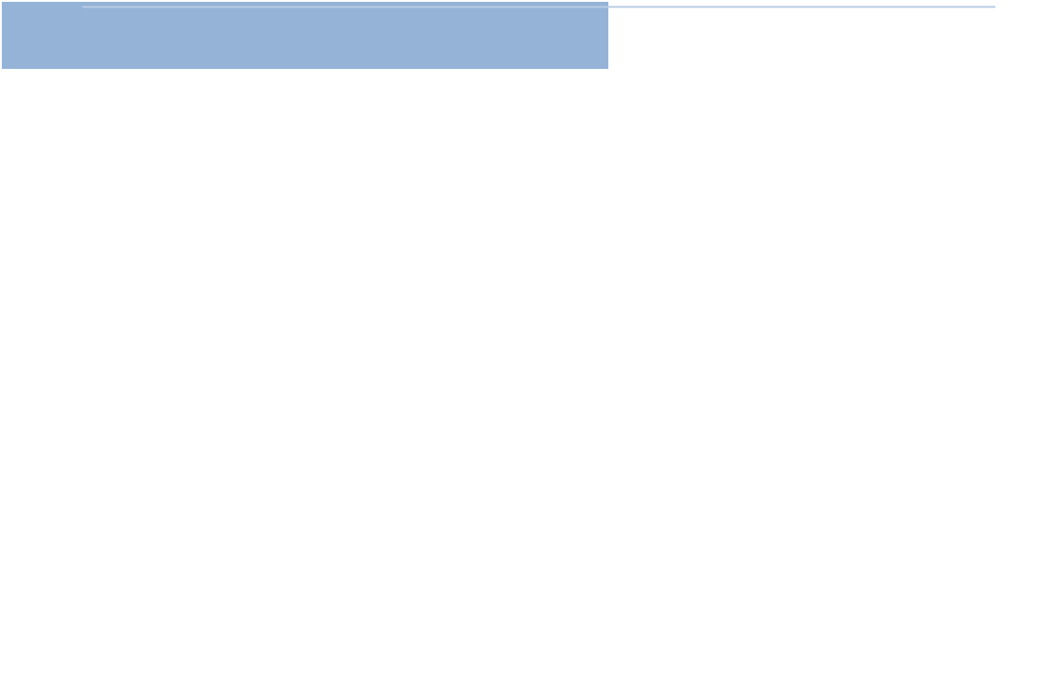

**Certificates Acquired**

|  |  |
| --- | --- |
| **Google IT Support Professional Certificate** | **2021** |
| **Google Digital Marketing Certificate** | **2021** |
| **Google – Coursera - Online** |  |
| **HNG Internship Certificate** | **2020** |
| **HNG Internship** |  |
| **Software Development Training Certificate** | **2020** |
| **StartNG.** |  |
| **Certificate of National Service** | **2016** |
| **National Youth Service Corps.** |  |
| **Basic Leadership Certificate** | **2016** |

**HillTop Leadership Institute**

**SKILLS**

Leadership Programming: HTML,

Python, CSS, Tailwind CSS, SASS, BOOTSTRAP, JavaScript, TypeScript REACTJS, NEXTJS, Firebase, Git/Github.

Microsoft office proficiency:

MS Office Suit.

ICT Competence / Friendly

Digital skills/Business skills: Front End Web Developer, Interface Developer, Networking, Customer support/service, Encryption, cryptology, Operating System, Troubleshooting, video editing etc.

**Education**

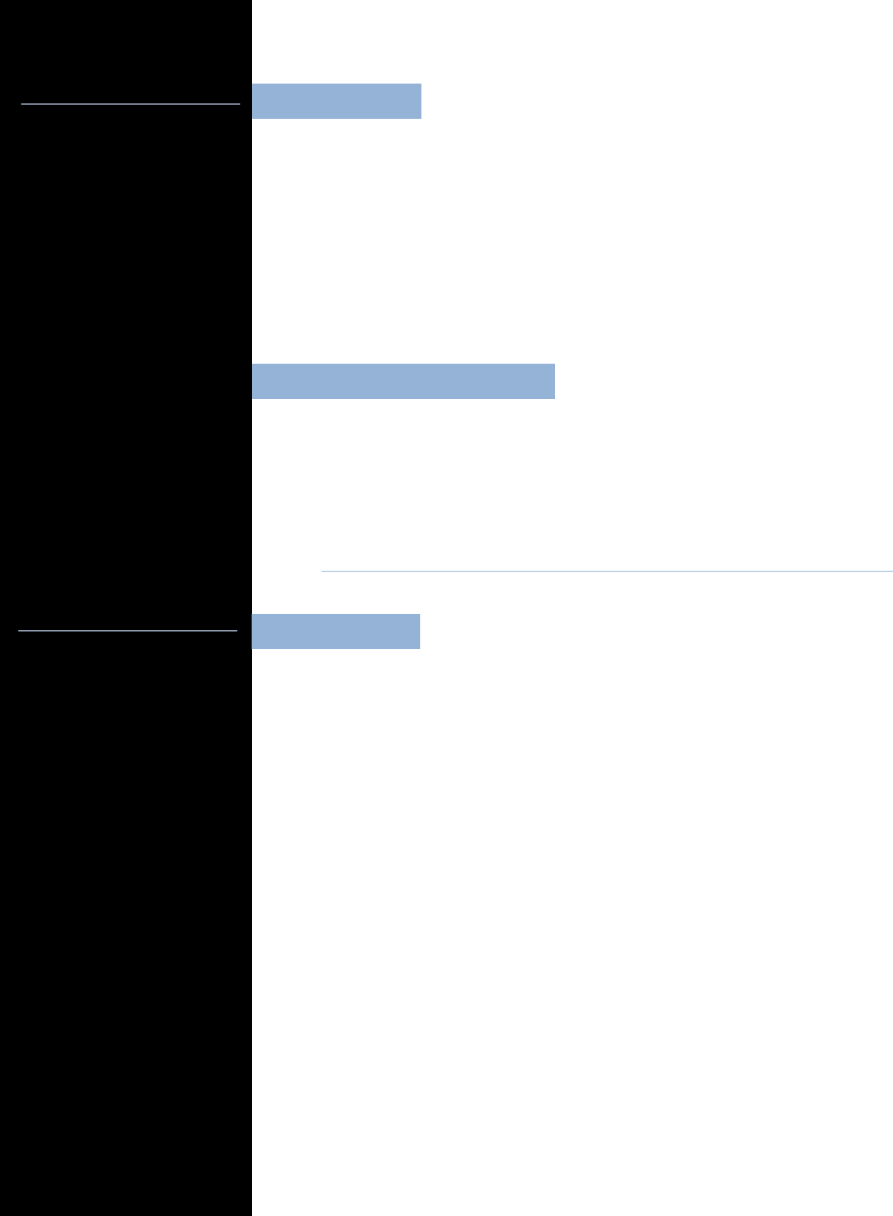

|  |  |  |
| --- | --- | --- |
| **(B.Agric) Second Class Honour (Upper Division)** | | **2015** |
| **University of Benin, Benin city, Nigeria.** | |  |
| **West African Examination Certificate (WAEC)** | | **2009** |
| **King Emmanuel College, Ore, Ondo State.** | |  |
| **First School Leaving Certificate** | | **2003** |
| **Key Way Nur / Pry School, Katsina State.** | |  |
|  |  |  |

**Awards/ Recent Promotion**

|  |  |
| --- | --- |
| **Head of Coding / ICT Schools** | **2019** |

**TeenCoders**

**INFORMATION**

Languages: English and Igbo

Hobbies : Watching movies, making research, Reading,

**Referees**

**Mercy Ikpe**

**Senior Frontend Developer**

**+2347013052599**

**Samuel Egbajie**

**Senior Fullstack Developer**

**07087126706**

**GITHUB LINK**

<https://github.com/princedev1993>